FIELD REPORT
Introduction
- Place: Acet HC III
- Location: Acet, Omoro district
- Date of visit: 1st September 2026
- General observations
- The verification exercise was successfully conducted with the support of the facility In charge, who provided the relevant documentation, including delivery notes and stock cards.
- All UgIFT-provided medical equipment and furniture were physically verified and confirmed to be present at the facility.
- The Health Unit Management Committee demonstrated strong cooperation and actively supported the verification exercise.
- Most of the verified UgIFT assets were found to be functional and in use by the facility.
Special notes
- Not assets engraved
- All four wheelchairs provided under UgIFT were found to be non-functional. According to the facility, the wheelchairs were already faulty at the time of delivery and have never been used since they were received. The four wheelchairs therefore remain idle and do not currently contribute to service delivery.
- The UgIFT-provided equipment was not engraved or otherwise clearly marked. This made it difficult to distinguish UgIFT assets from other assets owned by the facility.
- Some metallic beds and chairs showed signs of rust, which the facility attributed to poor storage conditions while the items remained packed. The continued exposure to unsuitable storage conditions may lead to further deterioration and reduce the lifespan of the assets.
Recommendations
The condition of the four wheelchairs at the time of delivery raises concerns regarding the inspection and quality assurance process before assets are accepted by facilities. A thorough quality and functionality inspection should be conducted at the delivery point before assets are formally accepted and handed over to the facility. Faulty items should be identified and replaced promptly.

The table below illustrates some physical status of the verified assets with photographic evidence.
Table XXX: Physical verification photos
ACET HC III SIGN POST | 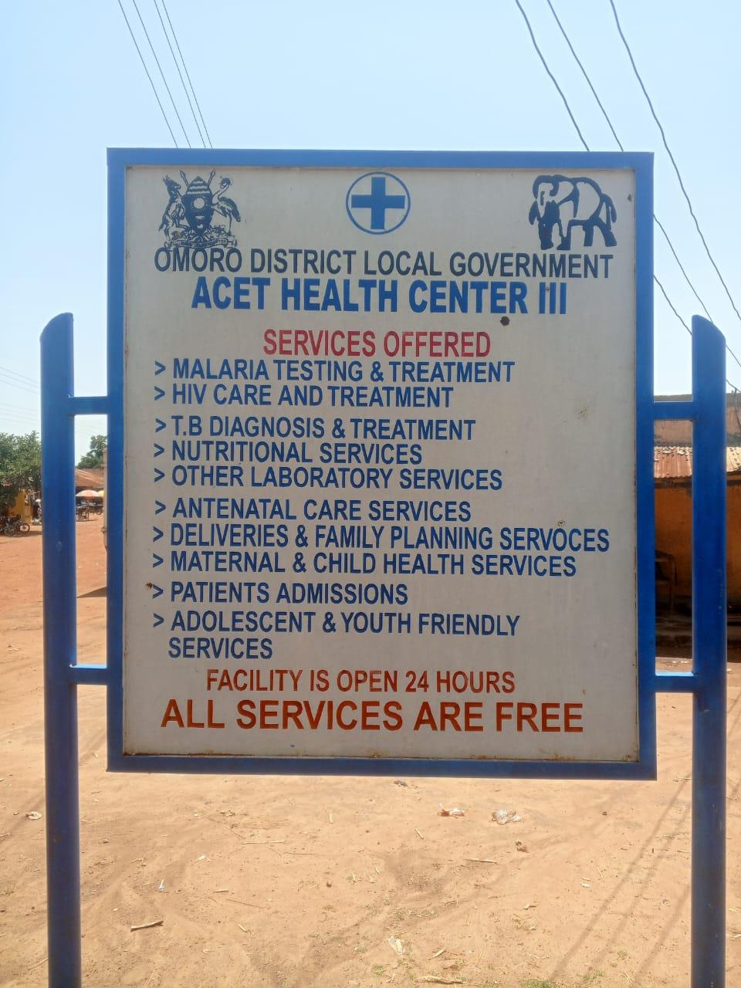
TYPICAL SET OF STAFF QUARTER’S BLOCK  (HOUSE BLOCK WITH TWO UNITS BLOCK) | 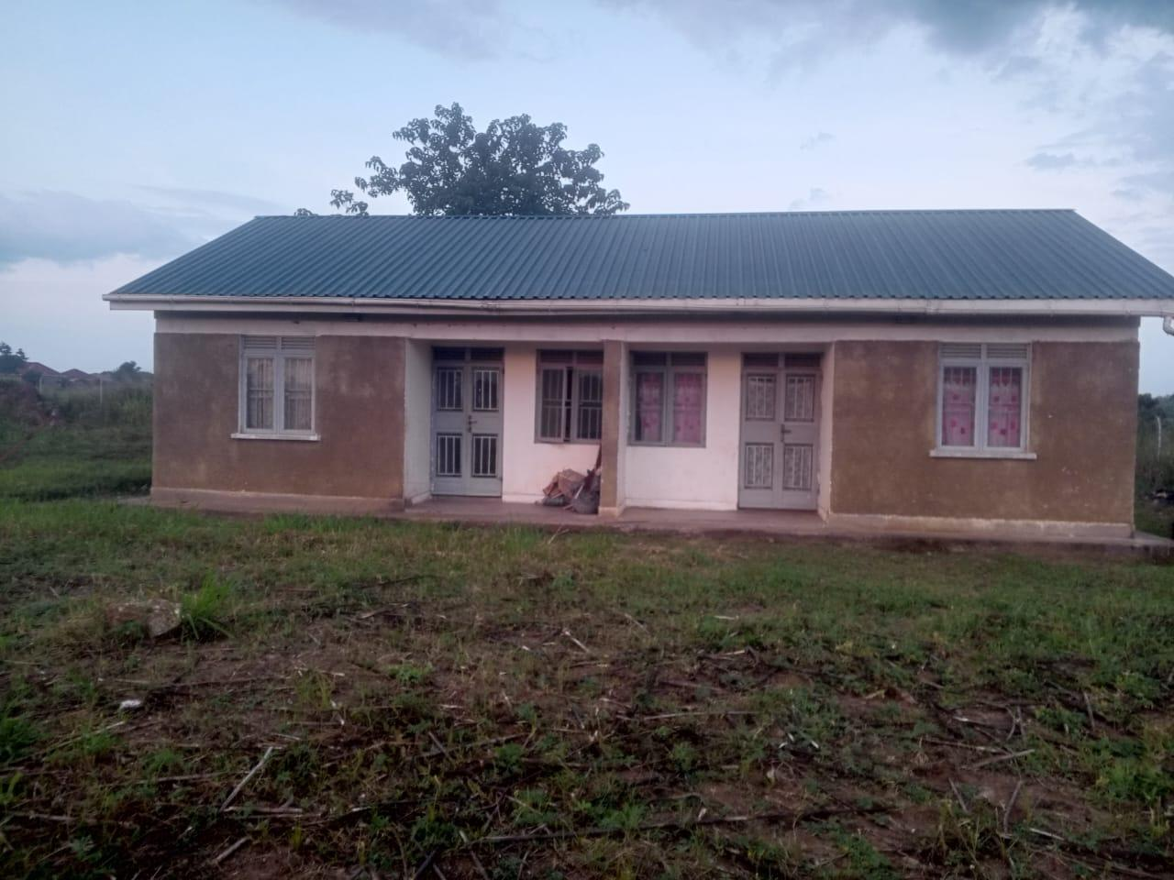
MATERNITY BLOCK (FRONT VIEW) | 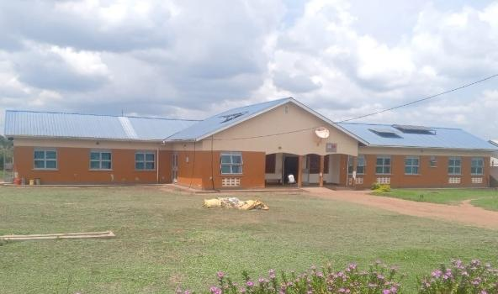
WATER TANKS (10000L) | 